WHAT DO I NEED?
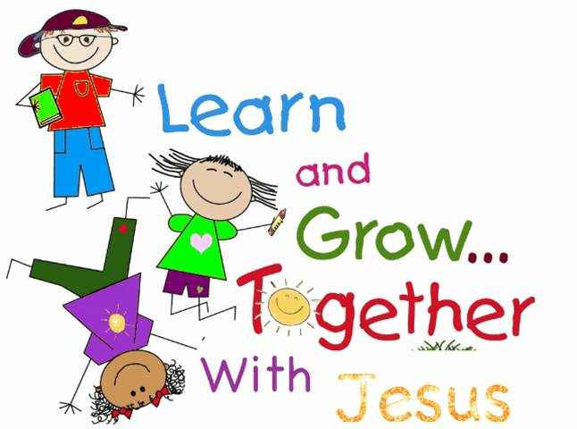
INFANTS:
- Bottles
- Food
- Change of Clothes
- Bibs
- Blanket (sheets provided)
- Diapers and Wipes
- Pacifier as needed
TODDLERS:
- AM and PM snack with drinks
- Lunch in a lunchbox and empty sippy cup (milk is provided)
- Crib sheet and small blanket for cot
- Change of clothes
- Diapers and wipes
- Pacifier as needed
TWO YEAR OLDS:
- AM and PM snack with drinks
- Lunch in a lunchbox and empty sippy cup (milk is provided)
- Crib sheet and small blanket for cot (in a backpack)
- Change of clothes
- Diapers or Pull-Ups and wipes
THREE AND FOUR YEAR OLDS:
- AM and PM snack with drinks
- Lunch in a lunchbox (milk is provided)
- Crib sheet and small blanket for cot (in a backpack)
- Change of clothes

